**Model-View-Controller (MVC) Pattern**

"Model-View-Controller" (MVC) is an architectural pattern that separates application code into three main components: Models, Views and Controllers.

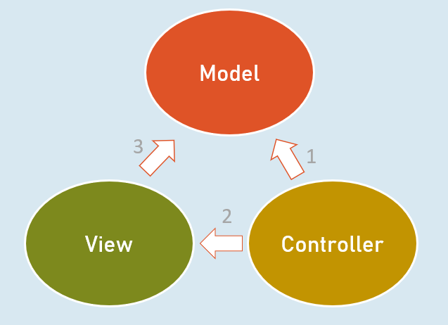

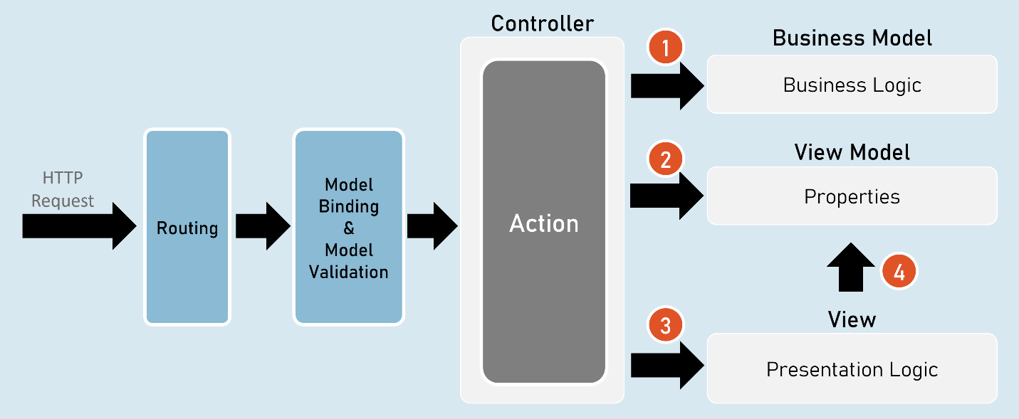

1. Controller invokes Business Model.
2. Controller creates object of View Model.
3. Controller invokes View.
4. View accesses View Model.

**Responsibilities of Model-View-Controller**

**Controller**

* Receives HTTP request data.
* Invoke business model to execute business logic.

**Business Model**

* Receives input data from the controller.
* Performs business operations such as retrieving / inserting data from database.
* Sends data of the database back to the controller.

**Controller**

* Creates object of ViewModel and files data into its properties.
* Selects a view & invokes it & also passes the object of ViewModel to the view.

**View**

* Receives the object of ViewModel from the controller.
* Accesses properties of ViewModel to render data in html code.
* After the view renders, the rendered view result will be sent as response.

**Benefits / Goals of MVC architectural pattern**

* Clean separation of concerns
* Each component (model, view and controller) performs single responsibility.
* Identifying and fixing errors will be easy.
* Each component (model, view and controller) can be developed independently.
* In practical, both view and controller depend on the model.
* Model doesn't depend on neither view nor the controller.
* This is one of the key benefits of the 'clean separation'.
* This separation allows the model to be built and tested independently.
* Unit testing each individual component is easier.

**Views**

View is a web page (.cshtml) that is responsible for containing presentation logic that merges data along with static design code (HTML).

* Controller creates an object of ViewModel and fills data in its properties.
* Controller selects an appropriate view and invokes the same view & supplies object of ViewModel to the View.
* View access the ViewModel.

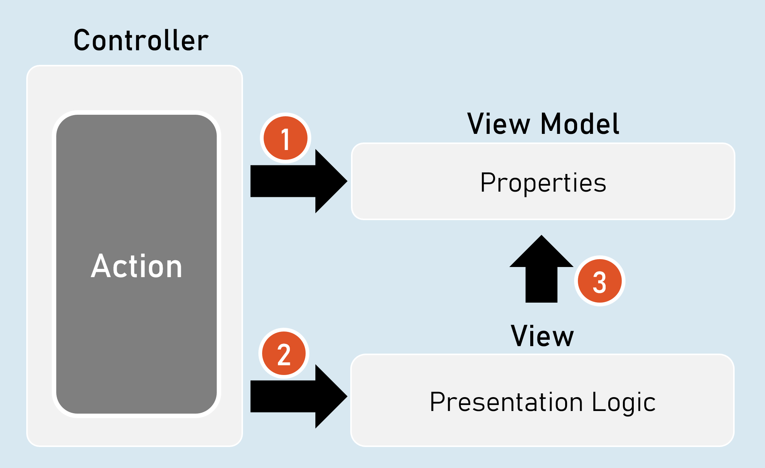

* View contains HTML markup with Razor markup (C# code in view to render dynamic content).
* Razor is the view engine that defines syntax to write C# code in the view. @ is the syntax of Razor syntax.
* View is NOT supposed to have lots of C# code. Any code written in the view should relate to presenting the content (presentation logic).
* View should neither directly call the business model, nor call the controller's action methods. But it can send requests to controllers.

**Razor View Engine**

**Razor Code Block**

@{

C# / html code here

}

Razor code block is a C# code block that contains one or more lines of C# code that can contain any statements and local functions.

**Razor Expressions**

@Expression

--or--

@(Expression)

Razor expression is a C# expression (accessing a field, property or method call) that returns a value.

**Razor - If**

@if (condition) {

C# / html code here

}

**Razor - if…else**

@if (condition) {

C# / html code here

}

else {

C# / html code here

}

Else…if and nested-if also supported.

**Razor - Switch**

@switch (variable) {

case value1: C# / html code here; break;

case value2: C# / html code here; break;

default: C# / html code here; break;

}

**Razor - foreach**

@foreach (var variable in collection ) {

C# / html code here

}

**Razor - for**

@for (initialization; condition; iteration) {

C# / html code here

}

**Razor - Literal**

@{

@: static text

}

**Razor - Literal**

<text>static text</text>

**Razor - Local Functions**

@{

return_type method_name(arguments) {

C# / html code here

}

}

The local functions are callable within the same view.

Razor - Members

**Razor - Methods, Properties, Fields**

@functions {

return_type method_name(arguments) {

C# / html code here

}

data_type field_name;

data_type property_name

{

set { … }

get { … }

}

}

The members of razor view can be accessible within the same view.

**Html.Raw( )**

@{

string variable = "html code";

}

@Html.Raw(variable) //prints the html markup without encoding (converting html tags into plain text)

**ViewData**

ViewData is a dictionary object that is automatically created up on receiving a request and will be automatically deleted before sending response to the client.

It is mainly used to send data from controller to view.

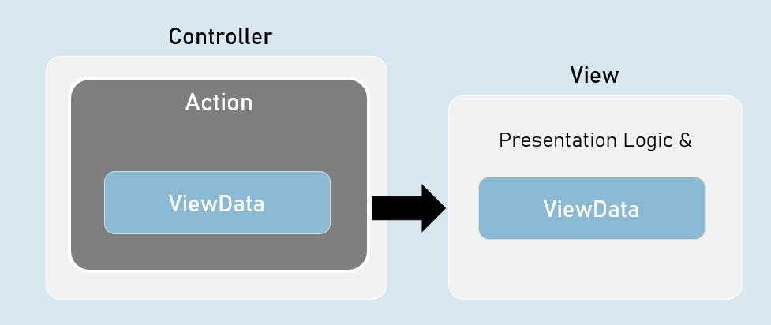

ViewData is a property of Microsoft.AspNetCore.Mvc.Controller class and Microsoft.AspNetCore.Mvc.Razor.RazorPage class.

It is of Microsoft.AspNet.Mvc.ViewFeatures.ViewDataDictionary type.

namespace Microsoft.AspNetCore.Mvc

{

public abstract class Controller : ControllerBase

{

public ViewDataDictionary ViewData { get; set; }

}

}

* It is derived from IDictionary<KeyValuePair<string, object>> type.
* That means, it acts as a dictionary of key/value pairs.
* Key is of string type.
* Value is of object type.

**ViewData - Properties and Methods**

* int Count { get; set; } //gets the number of elements.
* [string Key] //Gets or sets an element.
* Add(string key, object value) //Adds a new element.
* ContainsKey(string key) //Determines whether the specified key exists or not.
* Clear() //Clears (removes) all elements.

**ViewBag**

ViewBag is a property of Controller and View, that is used to access the ViewData easily.

ViewBag is 'dynamic' type.

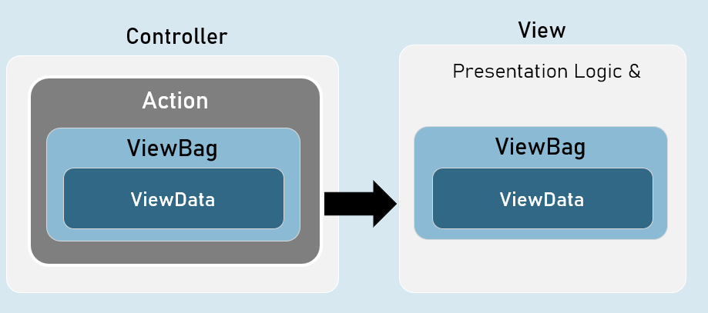

ViewBag is a property of Microsoft.AspNetCore.Mvc.Controller class and Microsoft.AspNetCore.Mvc.Razor.RazorPageBase class.

It is of dynamic type.

namespace Microsoft.AspNetCore.Mvc

{

public abstract class Controller : ControllerBase

{

public dynamic ViewBag { get; set; }

}

}

The 'dynamic' type similar to 'var' keyword.

But, it checks the data type and at run time, rather than at compilation time.

If you try to access a non-existing property in the ViewBag, it returns null.

[string Key] //Gets or sets an element.

**Benefits of 'ViewBag' over ViewData**

ViewBag's syntax is easier to access its properties than ViewData.

Eg: ViewBag.property [vs] ViewData["key"]

You need NOT type-cast the values while reading it.

Eg: ViewBag.object_name.property

[vs]

(ViewData["key"] as ClassName).Property

**Strongly Typed Views**

Strongly Typed View is a view that is bound to a specified model class.

It is mainly used to access the model object / model collection easily in the view.

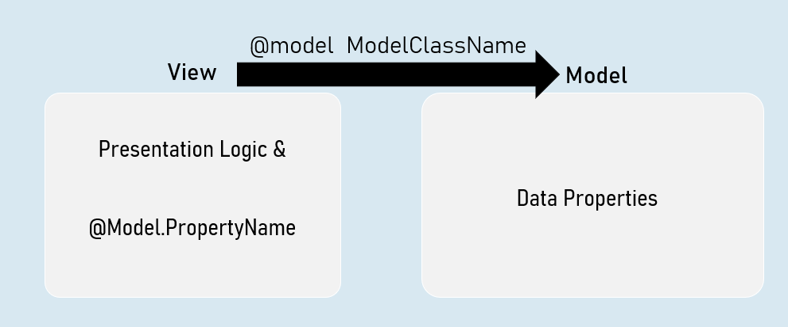

**Benefits of Strongly Typed Views**

* You will get Intellisense while accessing model properties in strongly typed views, since the type of model class was mentioned at @model directive.
* Property names are compile-time checked; and shown as errors in case of misspelled / non-existing properties in strongly typed views.
* You will have only one model per one view in strongly typed views.
* Easy to identify which model is being accessed in the view.

**Helper methods in Controller to invoke a View**

* return View( ); //View name is the same name as the current action method.
* return View(object Model ); //View name is the same name as the current action method & the view can be a strongly-typed view to receive the supplied model object.
* return View(string ViewName); //View name is explicitly specified.
* return View(string ViewName, object Model ); //View name is explicitly specified & the view can be a strongly-typed view to receive the supplied model object.

**Strongly Typed Views**

Strongly Typed View can be bound to a single model directly.

But that model class can have reference to objects of other model classes.

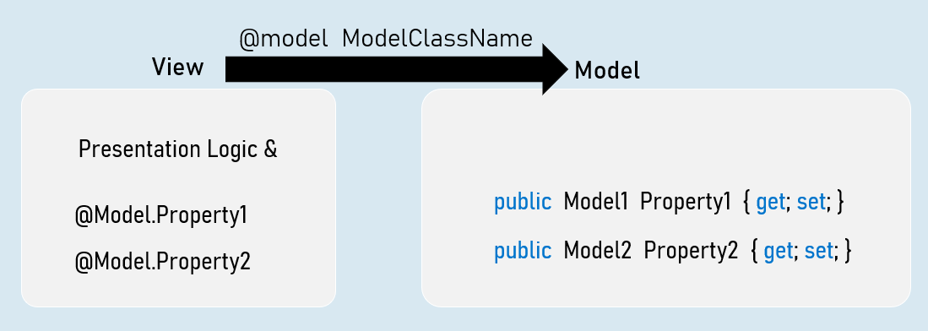

**ViewImports.cshtml**

ViewImports.cshtml is a special file in the "Views" folder or its subfolder, which executes automatically before execution of a view.

It is mainly used to import common namespaces that are to imported in a view.

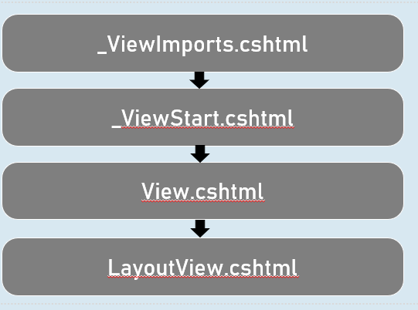

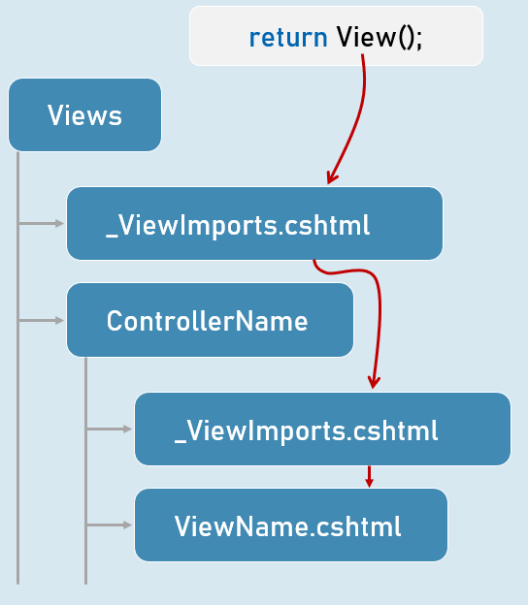

**Shared Views**

Shared views are placed in "Shared" folder in "Views" folder.

They are accessible from any controller, if the view is NOT present in the "Views\ControllerName" folder.

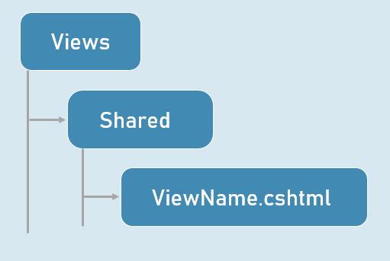

**View Resolution**

